Personal History Form

INSTRUCTIONS:
- Please answer each question clearly and completely.

- Read carefully and follow all directions. Please tick appropriate box.

- Please write in CAPITAL letter only.

Name (using in bank Account) | POOJA SHAHAJI BHAPKAR
Date of Birth  (as per school certificate) | 14/09/1997
Place of Birth | KEDGOAN
Father Name | SHAHAJI
Spouse Name | VISHAL
Present Nationality | INDIAN
Gender | FEMALE
Marital Status | MARRIED
Permanent address (with pin code) | A/P: KARKHEL TAL: BARAMATI DIST:PUNE
Present address  (with pin code) | A/P: KARKHEL TAL: BARAMATI DIST:PUNE
Permanent telephone #/Mobile/Landline | 7387125628
Present telephone/Mobile # | 7387125628
E-mail address | poojabhapkar88@gmail.com
Skype ID | live:.cid.cf1c34aaf651a34e
Income Tax Pan No  (attach Xerox copy) | DWWPB0896N
Adhaar Card No.  (attach Xerox copy) | 417449932542

Name (As per Bank records) | Bank A/c # | IFSC Code | Bank Name | Branch Name
POOJA SHAHAJI BHAPKAR | 60322264972 | MAHB0001409 | BANK OF MAHARASHTRA | JALOCHI TO BARAMATI

Emergency Contact Name & Ph #

Qualification: - M.Sc. STATISTICS

Total Work Experience before Joining Trivium: - 1 YEAR

By submission of this application I certify that the statements made by me in answer to the foregoing questions are true, complete and correct to the best of my knowledge and belief. I understand that any misrepresentation or material omission made on a Personal History Form or other document requested by the Trivium renders a staff member of the Trivium liable to termination or dismissal.

Name: POOJA SHAHAJI BHAPKAR

Signature:
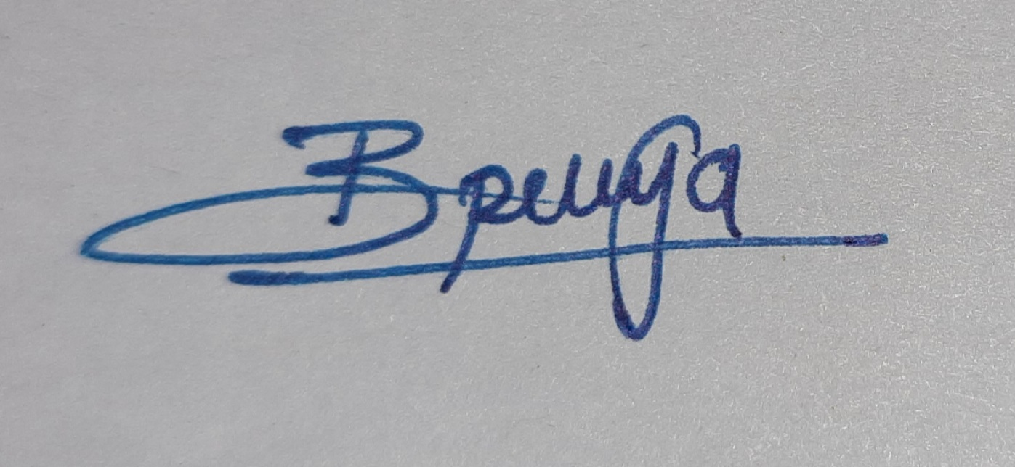

Date: 04/02/2021

